A An Truong Primary School.  Full name: Trần Thị Diệu Hiền  Class: 5/1 | THE FRIST TERM TEST FOR GRADE 5  School year: 2025-2026  Time allowed: 30 minutes
READING (2.5 MARKS )
Look and tick ☑ or cross 🗵.(2.5 marks)
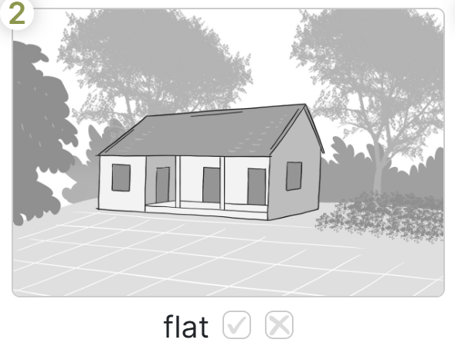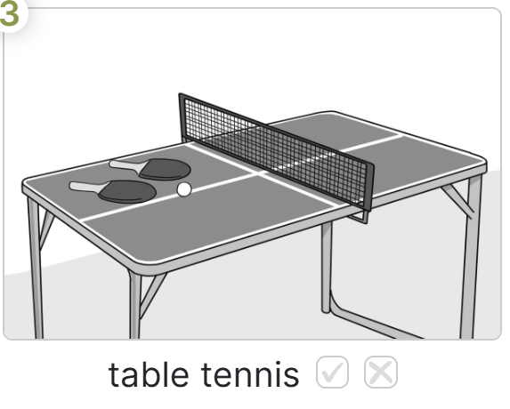

WRITING (2.5 MARKS)


Look and write. (2.5 mark)




amN

4
anialmyas
solfrew

ent

3
2
1

5

ayrM

A An Truong Primary School.  Full name: Nguyễn Minh Huy  Class: 5/1 | THE FRIST TERM TEST FOR GRADE 5  School year: 2025-2026  Time allowed: 30 minutes
READING (2.5 MARKS )
Look and tick ☑ or cross 🗵.(2.5 marks)
WRITING (2.5 MARKS)
Look and write. (2.5 mark)
amN

4
anialmyas
solfrew

ent

3
2
1

5
ayrM

